Project: Woodson Park Academy & YMCA-ELC
Week Ending: August 2nd, 2019

THIS WEEK:
- Building demo has resumed
- Tub grinder grinding stumps and tree tops
- Tree haul off

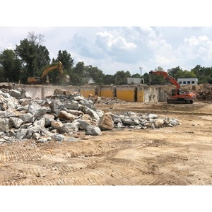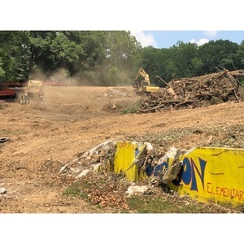

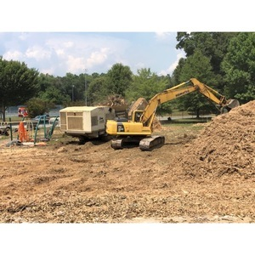

NEXT WEEK – August 5 thru August 9:
- Demo Continues
- Tire crew to remove tires
- Grubbing and tree haul off to continue

PAYMENT STATUS:
- Gmp#1 $3,703,488.00
  - Paid to date amount $0.00
- GMP#2 $28,686,295.00
  - Paid to date amount $0.00

SCHEDULED DATE OF SUBSTANTIAL COMPLETION
- WPA – September 17, 2020
- YMCA-ELC - September 14, 2020

PREPARED BY:
- Matt Dauber, Carroll Daniel Construction Co.

